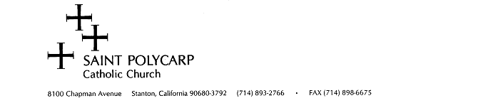
The Faith Formation program is built upon the ‘active faithful’ sharing their time and talents. Please consider how you or a family member can best assist us as we pass along our gift of faith to the youth of our parish.

NAME__________________________________________________________________________________
ADDRESS________________________________________________________________________________
CELL NUMBER_________________________________________________
EMAIL_______________________________________________________

□ I WOULD LIKE TO HELP WITH THE RCIA PROCESS

□ I WOULD LIKE TO TEACH IN GRADE: 1, 2, 3, 4, 5, 6, 7, 8 (circle)

□ I WOULD LIKE TO CO-TEACH IN GRADE: 1, 2, 3, 4, 5, 6, 7, 8 (circle)

□ I WOULD LIKE TO TEACH Confirmation Program Grades 9, 10, 11, 12 (circle)

□ I WILL BE A SUBSTITUTE IN GRADE: 1, 2, 3, 4, 5, 6, 7, 8 (circle)

□ I WILL HELP IN MY CHILD’S CLASS AS NEEDED Saturday morning 9:15-10:45 Monday evening 5:15-6:45
Tuesday evening 5:15-6:40 (Spanish)

□ I WILL HELP WITH THE PLANNING AND REHEARSALS FOR CHRISTMAS PLAY (Children’s Mass on Dec. 24)

□ I WILL HELP WITH THE CHILDREN’S RECONCILIATION RETREAT IN NOVEMBER

□ I WILL HELP WITH THE CHILDREN’S FIRST COMMUNION RETREAT IN APRIL

□ OTHERS WAYS I MAY BE ABLE TO OFFER MY ASSISTANCE
_____________________________________________________________
_____________________________________________________________

Please return to the Faith Formation Office, you may mail or place this in the collection basket marked Faith Formation. ALL volunteers are subject to our Safe Environment screening per diocese.
Thank you!

